

% Pam Benson

2116 Schmidt Ct. SE Phone/Fax 507- 287-8494

Rochester, MN 55904 cadzoom@hotmail.com

SIZES: Engraved in Indiana Limestone

____ 3 x 6 Pet Name only $25.00 + $7.00 shipping (in Continental US)
____ 5 x 10 Pet Name $30.00 + $7.00 shipping (in Continental US)
____ 5 x 10 Pet Name & Date $35.00 + $7.00 shipping (in Continental US) ____ Other Call or e-mail for pricing

TYPE STYLE:

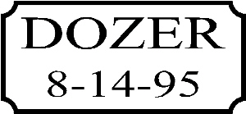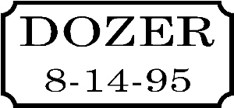
_____Times New Roman _____Century Schoolbook

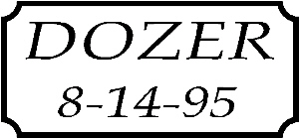

_____Book Antiqua Italic Other Font Choice_______________

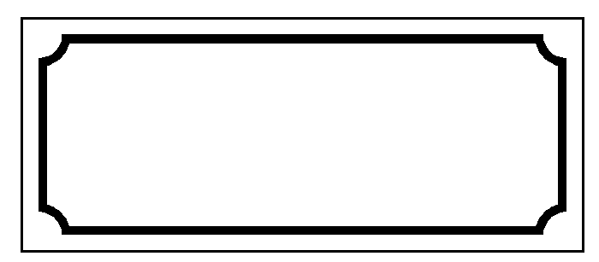
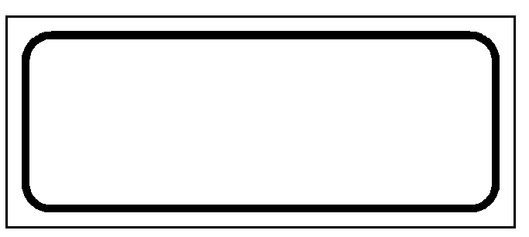
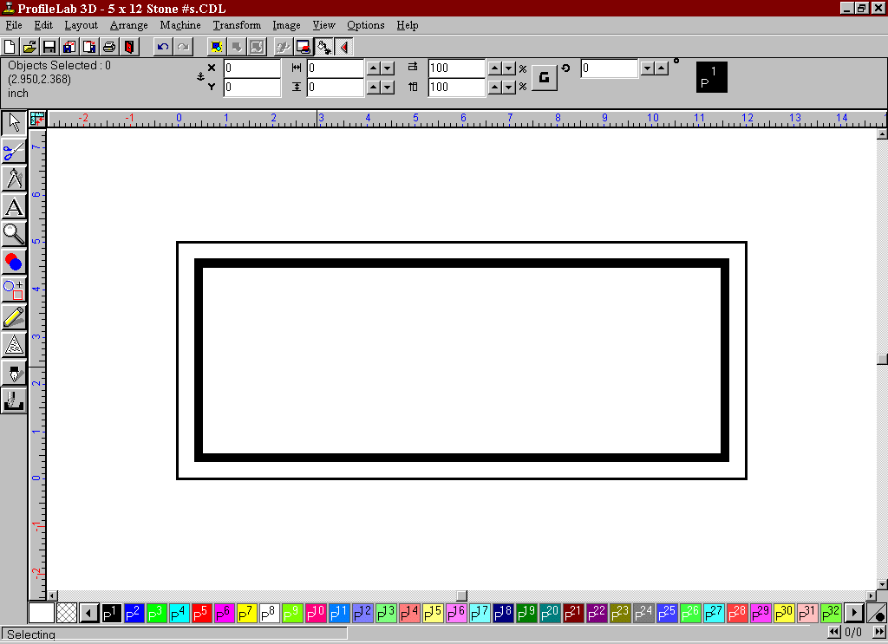BORDERS: Add $5.00
_____Square _____Inverse _____Rounded ____None

PET NAME TO BE INSCRIBED: _________________________________

Date to be inscribed: (8-14-95) ___________ NONE____
Shipping Information:
Name: __________________________ E-mail: ______________________________

Address: ________________________ State: __________ Zip Code: ____________

Total Due: ______________________
Please remember to include a pet photo with your payment. Write your name, address, and your pets name on the back of the photo. All photos will be returned with memorial.

